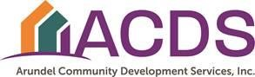

LAUREL RACE COURSE IMPACT FUND (LRCIF)

FY 2027 COMMUNITY GRANT APPLICATION GUIDELINES & INSTRUCTIONS

Please read all instructions before beginning the application.

This year, all LRCIF applications will be completed online through ACDS’s Neighborly Portal. To register your account, please follow the link below to be taken to the ACDS Neighborly Portal Login Page.

https://portal.neighborlysoftware.com/acds/Participant

A quick-guide for getting started with Neighborly can be found on the login page.

- Community Grants are available on a competitive basis to nonprofit organizations and community associations serving the community and residents within a three-mile radius of the Laurel Race Course. Eligible applicants may apply for $10,000 - $50,000. Larger grants may be approved for other projects on a case-by-case basis. Selected projects may be funded in whole or in part.

Community Grant applications must be submitted by 12:00 pm on Wednesday, December 17, 2025.

Community Grant applicants should complete the application through Neighborly. If you are unable to complete the application online, please contact tmullery@acdsinc.org to make alternate accommodations.

- All applicants must include evidence of the organization’s tax exempt (501(c)(3) or 501(c)(4)) status with the application. If the organization is a nonprofit organization, please include a copy of the organization’s IRS tax exempt letter. If you are a community organization (e.g. HOA, Condominium Association) please include a copy of the most recent federal tax return (federal form 1120 or 990).

- Grant funding can be used to purchase equipment and related supplies or to make small capital improvements such as renovation, remodeling, or restoration / beautification of buildings or public community spaces. Funding can be used to expand existing services or pilot test new programs, but CANNOT be used for general or recurring operating expenses.

- In making the awards, the Laurel Race Course Impact Fund Advisory Committee is often unable to meet the entire grant request. The application should describe how the organization would prioritize the expenditure of LRCIF funds if the full amount requested is not awarded.
- The grant review process will proceed as follows:

Page i

  - Grant applications will be initially screened for compliance then reviewed by the LRCIF Advisory Committee or a Grants subcommittee. Incomplete grant applications will not be considered, nor will any applications submitted after the deadline.

  - Grant finalists who are selected by the LRCIF Advisory Committee will be invited to make an in-person presentation to the Committee. Presentations will be scheduled for evenings in March 2026.

No more than 5 minutes will be allotted for the presentation, and PowerPoint presentations should be limited to no more than 10 slides.

  - The Committee will make final recommendations for each award and funding amount.

  - Recommendations for grant awards will then be reviewed and confirmed by the County Executive and approved by the County Council as part of the Anne Arundel County FY 2027 budget.

  - All applicants will be notified in writing of grant decisions.

Applicants who are selected to receive a LRCIF Grant will be required to enter into a grant agreement with Arundel Community Development Services, Inc. (ACDS), the agency under contract to administer the grants on behalf of the LRCIF Advisory Committee. This grant agreement will define the organization’s responsibilities and a payment schedule for the award received. Awardees may be required to attend an information session with ACDS staff. ACDS staff will contact the primary contact person listed in your application to begin processing the grant award and ensure the organization has submitted all required grant documents, including an Insurance Certificate naming ACDS as an additional insured and a board resolution or other organization document stating that the grant signatory is authorized to sign grant agreements on behalf of the organization.

If the organization is awarded funds, do not begin incurring expenses until the organization has a fully executed written agreement with ACDS. ACDS is not liable for any expenses incurred before the grant agreement is executed.

Once funds are awarded, grantees must:

- Follow ACDS invoicing procedures, including submittal of request for payments on organizational letterhead signed by an authorized representative with supporting back up material (original receipts, invoices). All funds are disbursed on a reimbursement basis.

- Submit progress reports and a final report once the project/program is complete; and

- Schedule a monitoring visit with ACDS staff while the program/project is in progress or completed. As part of the monitoring process, the Grantee will be required to share an organization-wide financial statement or an audit conducted by an independent accountant or a financial statement prepared in a manner approved by ACDS staff.
Questions? Please contact Tracey Mullery from ACDS at 410-222-3961 or tmullery@acdsinc.org.

Disclosure Protection

EXHIBIT I

Grantee shall adopt and maintain any and all policies and procedures necessary to provide its employees with Disclosure Protection consistent with § 6-2-107 of the Anne Arundel Code. Below are guidelines to use when preparing policies.

- Definition. In this section, a “personnel action” means an act, a refusal to act or an omission by an appointing authority which has a significant adverse impact on the employee or a change in the employee’s responsibilities which is inconsistent with the employee’s grade and salary.

- Action by appointing authority. Unless a disclosure is specifically prohibited by law, an employee may not be subject to a personnel action by an appointing authority as a reprisal for seeking any remedy under this section or for a disclosure to a federal, State or County official or employee, that the employee reasonably believes, in good faith, demonstrates evidence of:
  - retaliation for a refusal to obey an instruction of an appointing authority or supervisor involving an illegal act or a refusal to participate in an illegal act;
  - an illegal action in County government;
  - an unauthorized use of County funds; or
  - a substantial and specific danger to public health or safety.

- Other action authorized. This section does not prohibit a personnel action that otherwise would have been taken regardless of the disclosure.

- Disclosures to State officers. An employee has the same protections provided in subsection
(b) of this section regarding a disclosure that is specifically prohibited by law, if the disclosure is made to the Office of the State’s Attorney, the Office of the Attorney General of Maryland, or the Office of the Maryland State Prosecutor.

- Other remedies. This section does not preclude the aggrieved employee from seeking any legal action or other remedies available.

(Bill No. 17-11)

EXHIBIT II
Obtaining a printout of Good Standing Status from the Maryland Department of Assessments and Taxation

Information about business entities can be found at the Maryland State Department of Assessments
and Taxation (“SDAT”) website by searching for “Certificate of Status”. A direct link to the appropriate page is here:
https://egov.maryland.gov/BusinessExpress/EntitySearch

From the center of the page, in the “Business Name” search bar, enter the name or a part of the name of the entity. There should be no spaces between words, and you should not include the words “the” or “and”. Also, do not include any “tail” such as “Inc.” or “LLC”. If you only search part of the name, follow the part with “%” for a wildcard search.

It will give you the entity’s name, status with the SDAT, and whether the entity is in good standing with SDAT.

A paid SDAT Certificate is not required.

A printout of entity detail from the Maryland Department of Assessments and Taxation webpage
indicating the organization’s good standing is acceptable.

Please note that if the entity is listed as “forfeited” or not in good standing with SDAT, it cannot enter
into a contract with the County until the forfeiture or lack of good standing is resolved.

EXHIBIT III
Sample Form W-9
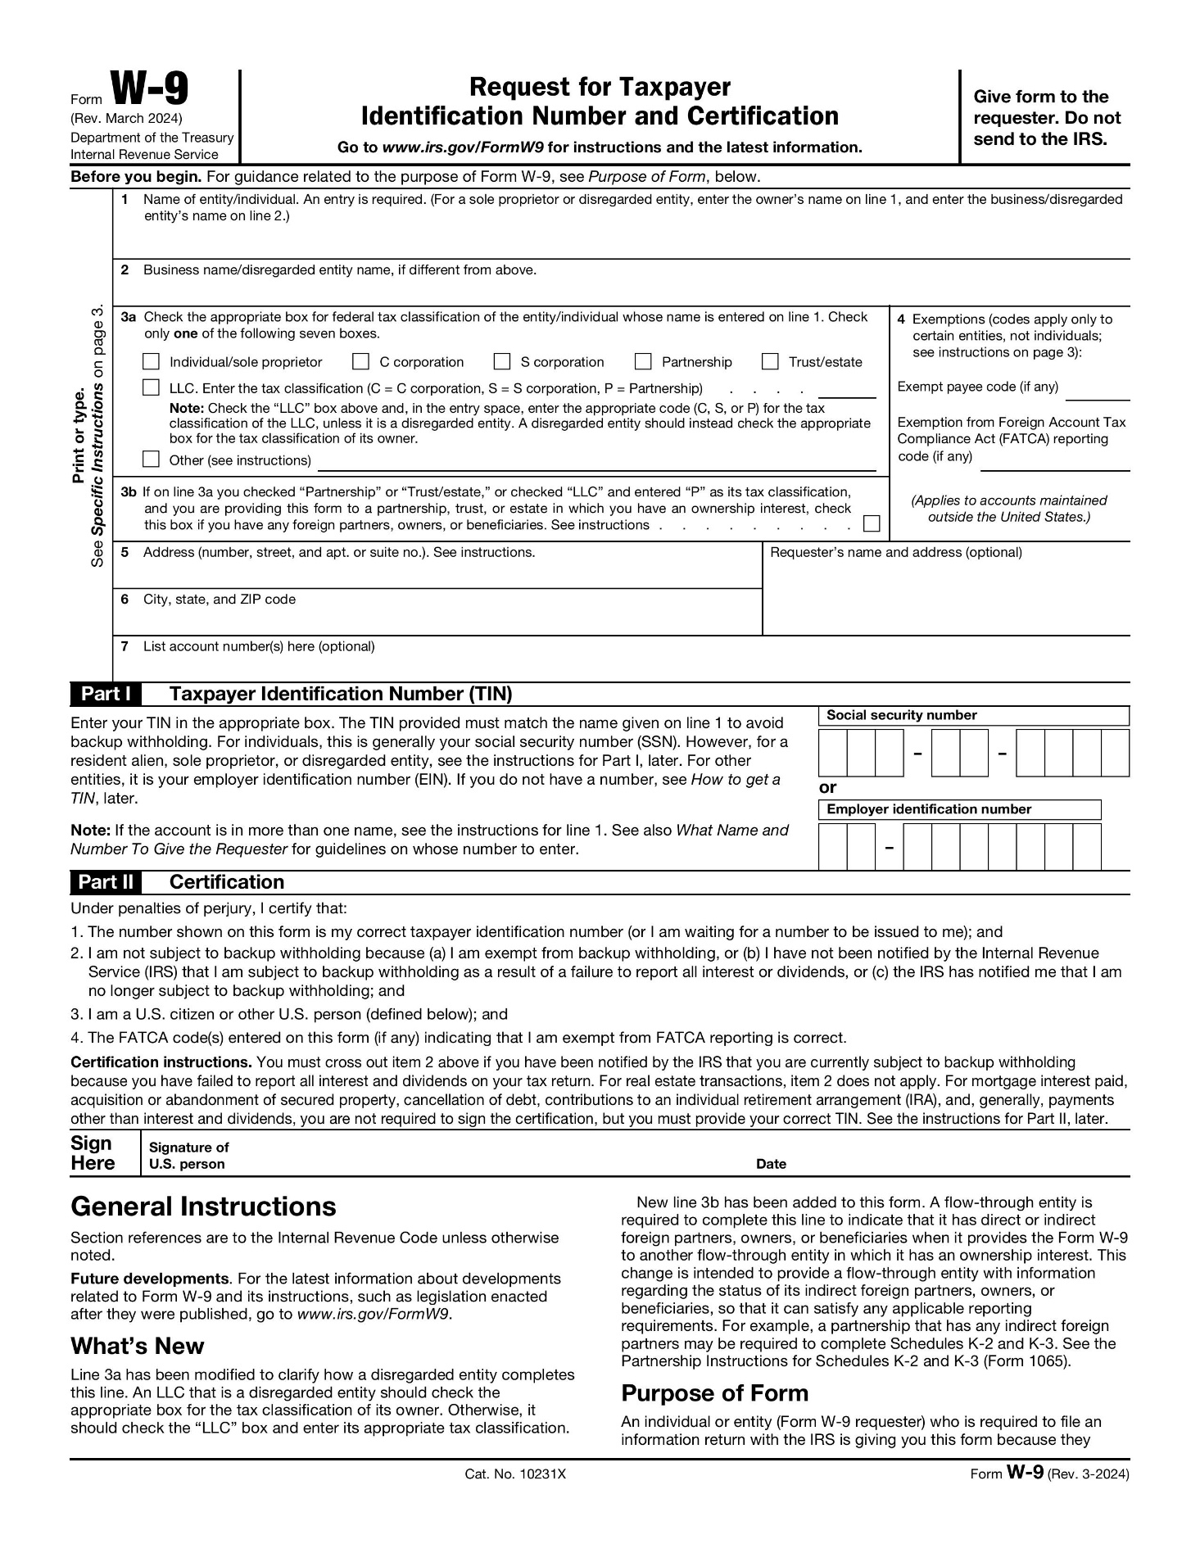

EXHIBIT IV
Insurance Requirements for Awarded Organizations
Grantee shall comply with the following insurance requirements governing the LRCIF and provide the Grant Administrator, at the time of execution of the grant agreement, with an active Certificate of Liability Insurance evidencing type of insurance, effective and expiration dates and the coverage limits. Grantee shall purchase and maintain the following insurance policies and amounts while grant agreement is in effect.

INSURANCE REQUIREMENTS
Grantee Insurance Requirements – All Grantees must carry the following insurance coverage.

- Comprehensive General Liability - All Grantees must carry commercial general liability with minimum limits of coverage at $1,000,000 Each Occurrence (Bodily Injury or Property Damage), $2,000,000 General Aggregate that applies on a per project basis, $2,000,000 Products/Completed Operations Aggregate and $1,000,000 Per Person or Organization (Personal and Advertising Injury).

In addition, ACDS must be provided with an additional insured for number CG 20 10 11 85 or a relative equivalency for all liability policies, except for worker’s compensation and automobile liability policies. Additional insured status to remain in effect for the term of the contract, including the warranty period.

- Property/Fire Insurance – All Grantees must carry property/fire insurance on any building or structure that is to be improved utilizing LRCIF funds. Insurance coverage must be in an amount not less than the value of the improvements,

- Automobile Liability Insurance – As applicable, all Grantees must carry automobile liability insurance coverage with least $1,000,000 combined single limit coverage to include owned, non-owned and hired automobiles

- Directors and Officers Insurance – Grantees receiving LRCIF over $100,000 must carry directors and officers insurance in an amount not less than One Million Dollars ($1,000,000), and

- Workers’ Compensation Insurance – As applicable, all Grantees must carry worker’s compensation insurance coverage for all of its employees in compliance with the Workers’ Compensation laws of the State of Maryland.

Contractors/Consultant Insurance Requirements – All Contractors and Consultants hired by the Grantee utilizing LRCIF funds must carry the following insurance coverage.

- Comprehensive General Liability - All Grantees must carry commercial general liability with minimum limits of coverage at $1,000,000 Each Occurrence (Bodily Injury or Property Damage), $2,000,000 General Aggregate that applies on a per project basis, $2,000,000 Products/Completed Operations Aggregate and $1,000,000 Per Person or Organization (Personal and Advertising Injury).

In addition, ACDS must be provided with an additional insured for number CG 20 10 11 85 or a relative equivalency for all liability policies, except for worker’s compensation and automobile liability policies. Additional insured status to remain in effect for the term of the contract, including the warranty period.
- Property Insurance – Contractors and Consultants must carry property/fire insurance on any building or structure that is to be improved utilizing LRCIF funds. Insurance coverage must be in an amount not less than the value of the improvements,

- Automobile Liability Insurance – As applicable, all Contractors and Consultants must carry automobile liability insurance coverage with least $1,000,000 combined single limit coverage to include owned, non-owned and hired automobiles,
- Workers’ Compensation Insurance – As applicable, all Contractors and Vendors must carry worker’s compensation insurance coverage for all of its employees in compliance with statutory benefits as required by the laws of the State of Maryland and employee’s liability coverage with limits of at least $100,000 each accident, $100,000 employee disease, and
$500,000 disease policy limits,
- Builder’s Risk Insurance – For all capital improvement projects over $250,000 the
Contractor or Grantee must carry builder’s risk insurance in an amount equal to the value of the improvements, and
- Errors and Omission Insurance – For all capital improvement projects over $250,000 the Consultant must carry errors and omission insurance in an amount not less than
$1,000,000.
- Umbrella Insurance – For all capital projects over $1,000,000 the Contractor must carry umbrella insurance in an amount of not less than $2,000,000.

INSURANCE CERTIFICATE AND ADDITIONAL INSURED REQUIREMENTS
Grantee Insurance Certificates – The Grantee must furnish Arundel Community Development Services, Inc. with certificates evidencing the type, amount, class of operations and effective dates of expiration of the insurance policies except for worker’s compensation and automobile polices. The insurance coverage certification shall include substantially the following statement: “The insurance covered by this certification shall not be canceled or materially altered, except after thirty (30) consecutive calendar days from when a written notice has been delivered to the Arundel Community Developments Services, Inc.”, whom shall be named as an additional insured in all insurance policies except for workers’ compensation and automobile liability policies.

Contractor and Consultant Insurance Certificates – The Grantee must furnish ACDS with insurance certificates from all Contractors and Consultants evidencing the type, amount, class of operations

and effective dates of expiration of the insurance policies except for worker’s compensation and
automobile polices.

INSURANCE WAIVER REQUEST
A request for a waiver for not carrying a specific type of required insurance must be made on applicant’s official letterhead to Arundel Community Development Services, Inc. at the time of submission of the grant application, with appropriate supporting documentation if applicable, including a description of circumstances sufficient to show why compliance is impossible. Grantee shall submit: a) certificate of insurance; and b) a letter requesting a waiver if certificate does not show evidence of a particular required insurance. Upon review/evaluation, Arundel Community Development Services, Inc. will inform the applicant of the approval or denial of a waiver request, or request additional information or documentation as necessary.

